JAVA SCRIPT ASSIGMENT USING REACT JSX FILES

ASSIGMENT -3

NAME : DODIYA NIYA Y.

ROLL NO:2199

DIV:FA2

SUBJECT:WAD(PRECTICAL)

1. The given React.js program defines a class-based component named EntryItem. This

component displays expense details (Item Name, Amount, Spend Date, and

Category) using JSX. The component is styled using an external CSS file

(ExpenseEntryItem.css).

import React, { Component } from 'react';

import Demo from './Demo';

// import '../styles/ExpenseEntryItem.css'

import './App.css'

class Democlas extends React.Component {

    render(){

    return(

        <>

        {/* <h1>Class Component</h1> */}

        {this.demo1()}

        {this.demo2()}

        {}

        </>

    )

}

demo1(){

    return <h1>Expense Details</h1>

}

demo2(){

    return(

        <>

        <div><b>Item:       </b><em>T-shirt</em></div>

        <br/>

        <div><b>Amount:     </b><em>3000.00</em></div>

        <br/>

        <div><b>Spend Date: </b><em>2025-04-05</em></div>

        <br/>

        <div><b>Category:   </b><em>Cloths</em></div>

        <br/>

        </>

    )

}

}

export default Democlas;

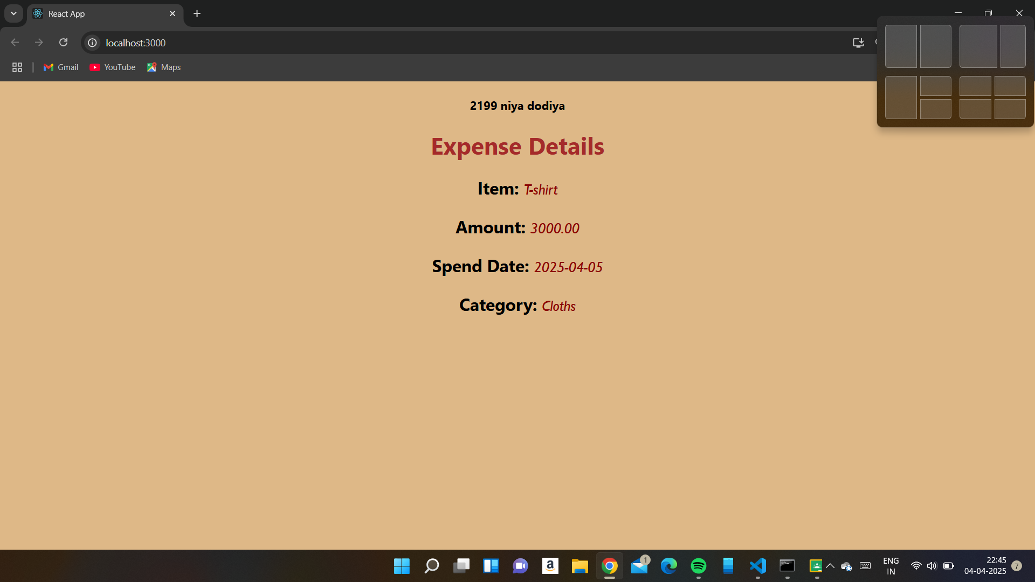

2. Create React.js Program Celsius to Fahrenheit Converter using a React function

import React, { useState } from "react";

function Fernhitconverter() {

    // render()

    const [celcius,setcelcius] = useState('');

    const [fernhit,setfernhit] = useState(null);

    const convertering = () => {

        const c= parseFloat(celcius);

        if(!isNaN(c)){

            const f=(c*9)/5+32;

            setfernhit(f.toFixed(2))

        }

        else{

            setfernhit("Invalid input")

        }

    }

    // render(){

        return(

            <>

            <input

            type="text"

            value={celcius}

            onChange={(e) => setcelcius(e.target.value)}

            />

            <button onClick={convertering}>click me!</button>

            <h2>fernhit : {fernhit !== null ? fernhit : '--'}</h2>

            </>

        )

}

export default Fernhitconverter;

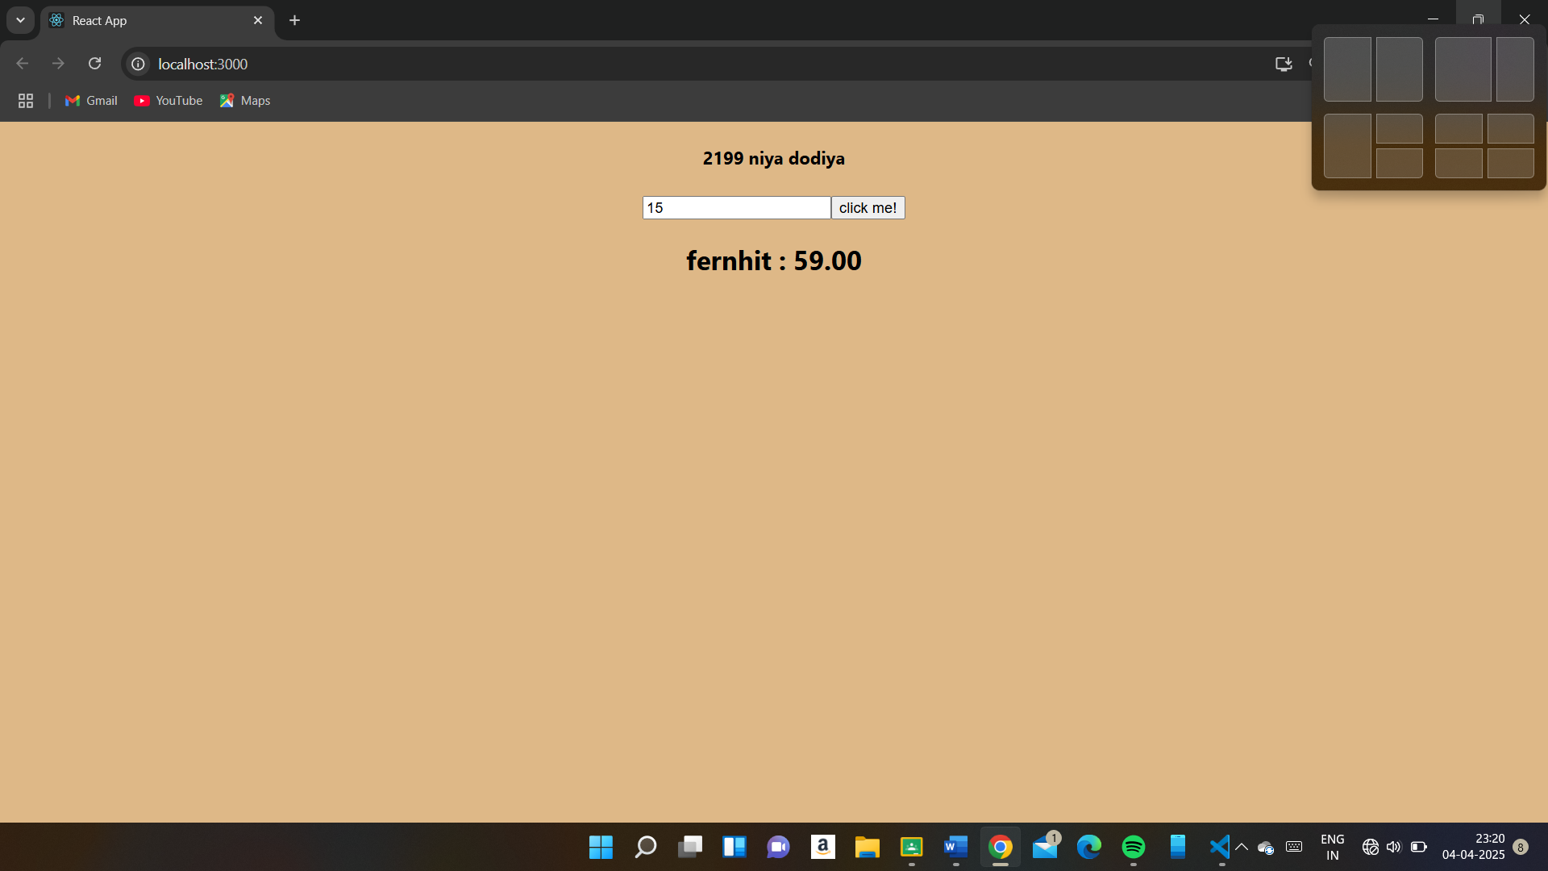

component. It allows the user to input a temperature in Celsius and, upon clicking

the "Convert" button, displays the equivalent temperature in Fahrenheit. React

application takes user input, processes it using a function, and updates the UI

dynamically.

3. React.js application that takes a student's name and their scores in Python, Java,

and JavaScript, calculates the average score, assigns a grade, and displays the results

dynamically. Ensures the input is a number before performing calculations. If input is

invalid, an error message is shown.

import React, { useState } from 'react';

function Studentsmarks() {

    const [name,setname] = useState('');

    const [java,setjava] = useState('');

    const [python,setpython] = useState('');

    const [js,setjs] = useState('');

    const [result,setresult] = useState('');

const calculateaverage = () => {

    const py = parseFloat(python);

    const jv = parseFloat(java);

    const jsscore = parseFloat(js);

   if (!name || isNaN(py) || isNaN(jv) || isNaN(jsscore)) {

      setresult('Please enter valid name and marks for all subjects.');

    //   setAverage(null);

    //   setGrade('');

      return;

    }

    const average=(py+jv+jsscore)/3;

    let grade='';

    if (average >= 90) grade='A+';

    else if (average >= 80) grade='A';

    else if (average >= 70) grade='B';

    else if (average >= 60) grade='C';

    else if (average >= 50) grade='D';

    else if (average >= 40) grade='E';

    else grade='Fail';

    setresult(`NAME : ${name}\n AVERAGE IS : ${average.toFixed(3)} GRADE IS : ${grade}`);

    };

    return(

        <>

        <h2>Student Geade Calculation</h2>

        <input

        // type="text"

        value={name}

        placeholder='enter the name'

        style={{ height: "35px",width: "200px",backgroundColor: "lightpink"}}

        onChange={(e) => setname(e.target.value)}

        />

        <br/><br/>

        <input

        // type="number"

        value={python}

        placeholder='enter the python marks'

        style={{ height: "35px",width: "200px",backgroundColor: "lightpink"}}

        onChange={(e) => setpython(e.target.value)}

        />

        <br/><br/>

        <input

        // type="number"

        value={java}

        placeholder='enter the java marks'

        style={{ height: "35px",width: "200px",backgroundColor: "lightpink"}}

        onChange={(e) => setjava(e.target.value)}

        />

        <br/><br/>

        <input

        // type="number"

        value={js}

        placeholder='enter the js marks'

        style={{ height: "35px",width: "200px",backgroundColor: "lightpink"}}

        onChange={(e) => setjs(e.target.value)}

        />

        <br/><br/>

        <button onClick={calculateaverage} style={{color: "red",backgroundColor: "lightblue",width: "100px",height: "35px"}}>click me!</button>

        <br/>

        <h2>Result : {result}</h2>

        </>

    )

}

export default Studentsmarks;

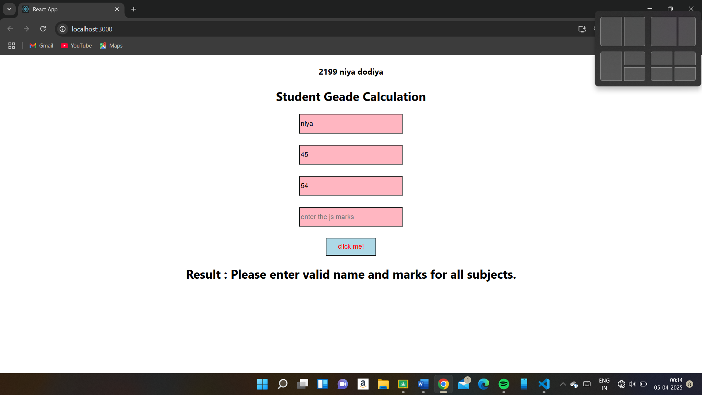

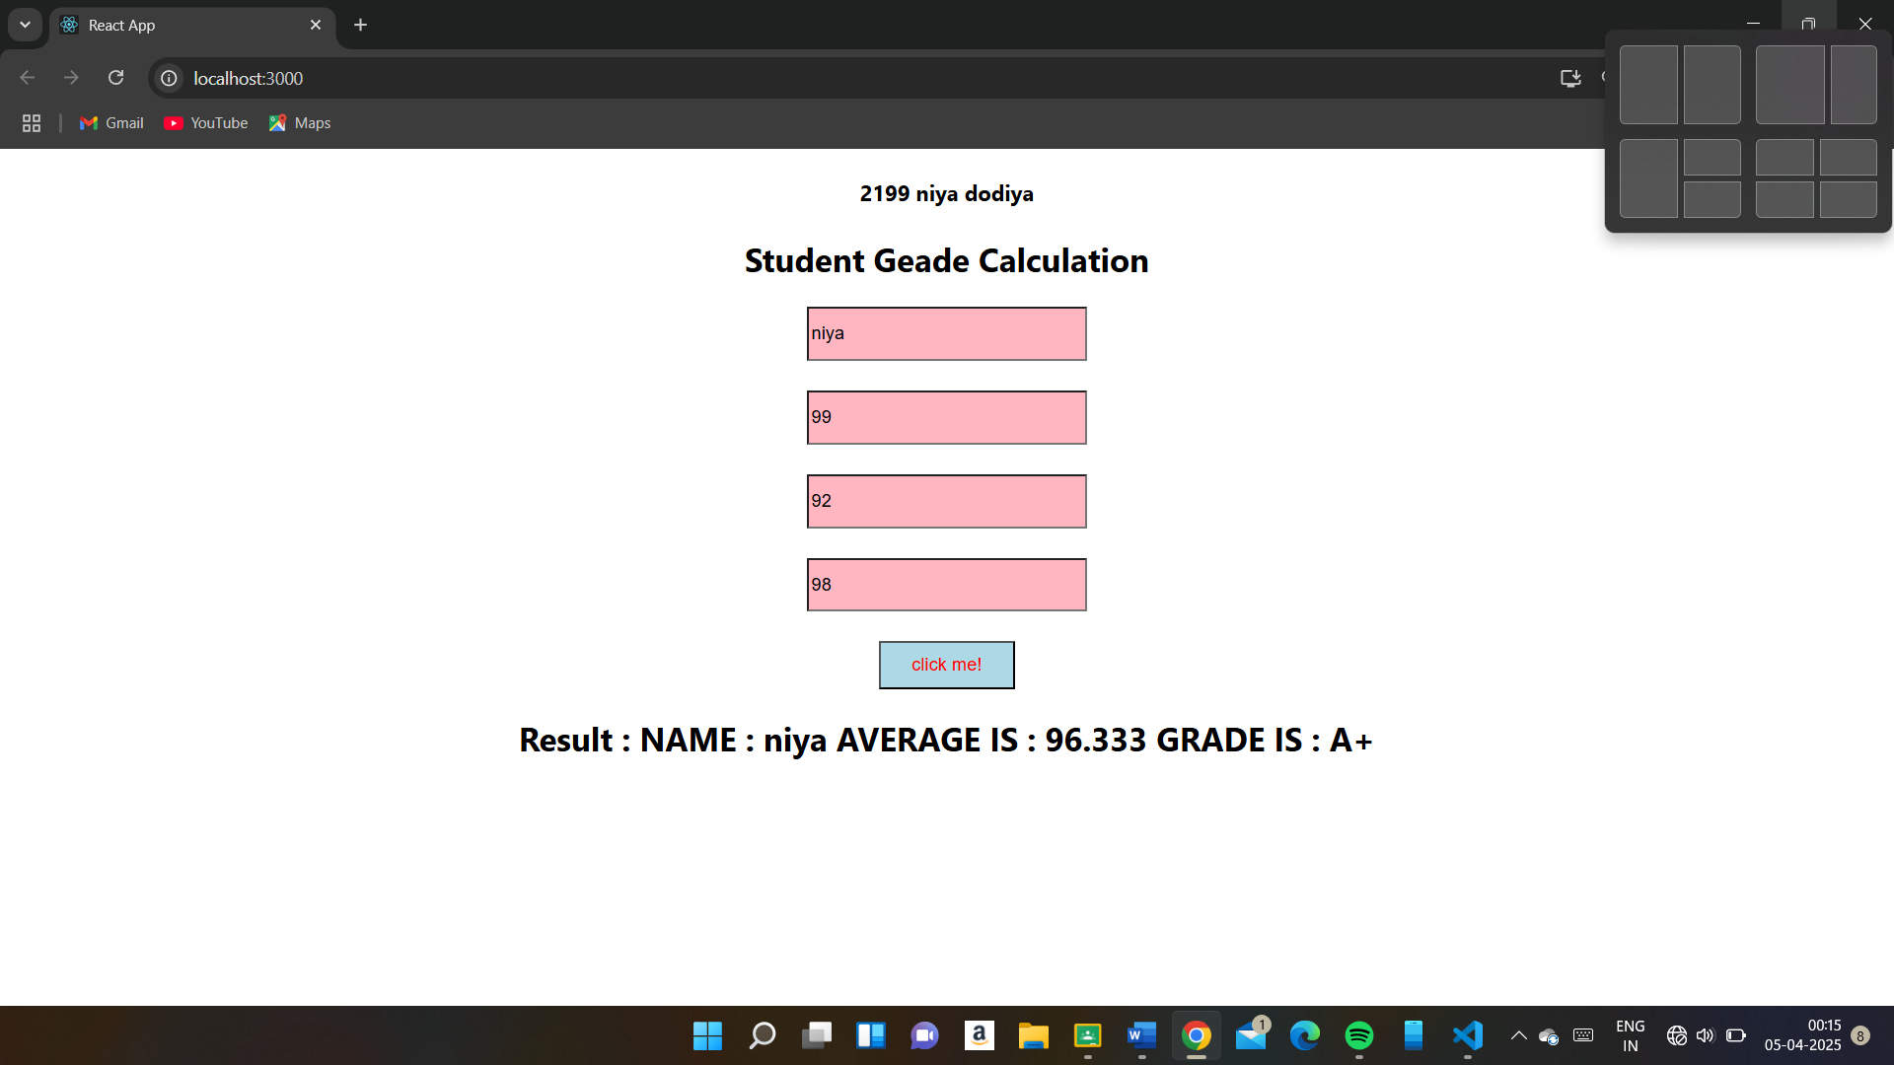

4. Create React.js Program to make calculator using a React Function Component.Use

num1, num2 and displays the result dynamically.

import React, { useState } from "react";

function Calculator() {

const [num1, setNum1] = useState("");

const [num2, setNum2] = useState("");

const [result, setResult] = useState("");

//Calculate function

// const calculate = () => {

// const n1 = parseFloat(num1);

// const n2 = parseFloat(num2);

function calculate() {

const n1 = parseFloat(num1);

const n2 = parseFloat(num2);

if (!isNaN(n1) && !isNaN(n2)) {

const results = `

Addition: ${n1 + n2}

Subtraction: ${n1 - n2}

Multiplication: ${n1 * n2}

Division: ${n2 !== 0 ? (n1 / n2).toFixed(2)

: "Division by zero!"}

`;

setResult(results);

} else {

alert("Please enter valid numbers.");

}

};

return (

<div>

<h1>Math Operations</h1>

<p>Enter two numbers to perform basic

operations:</p>

<label><h2>Number 1: </h2></label>

<br/>

<input

type="number"

value={num1}

onChange={(e) => setNum1(e.target.value)}

/>

<br />

<br />

<label><h2>Number 2: </h2></label>

<br/>

<input

type="number"

value={num2}

onChange={(e) => setNum2(e.target.value)}

/>

<br />

<br />

<button onClick={calculate}>Calculate</button>

{/* {result && (

<span>{result}</span>

)} */}

<p>Ans is {result}</p>

</div>

);

};

export default Calculator;

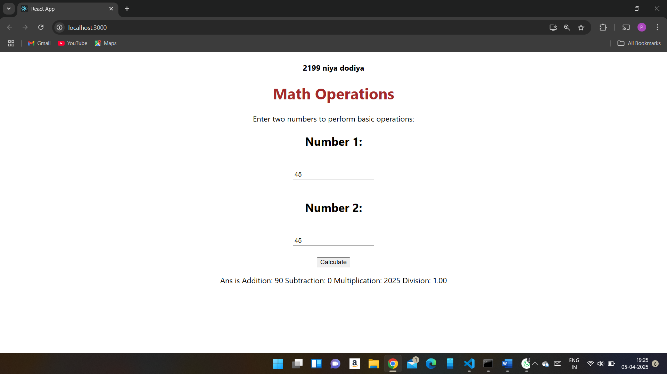

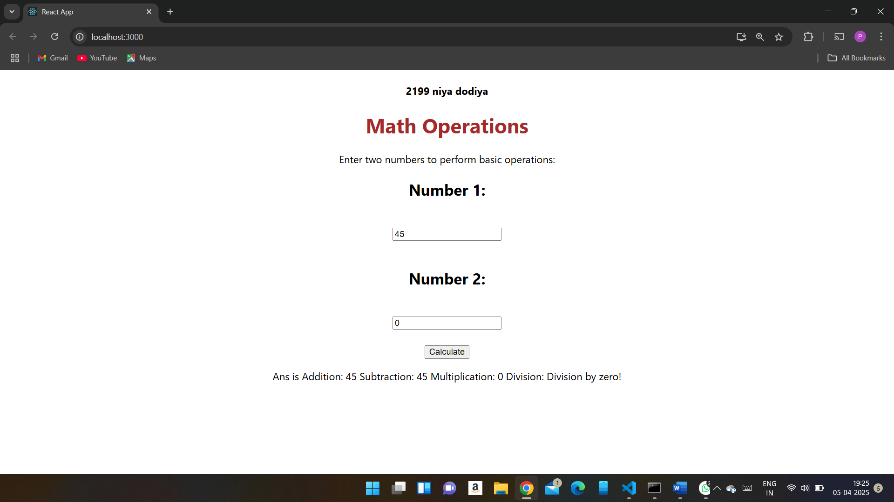

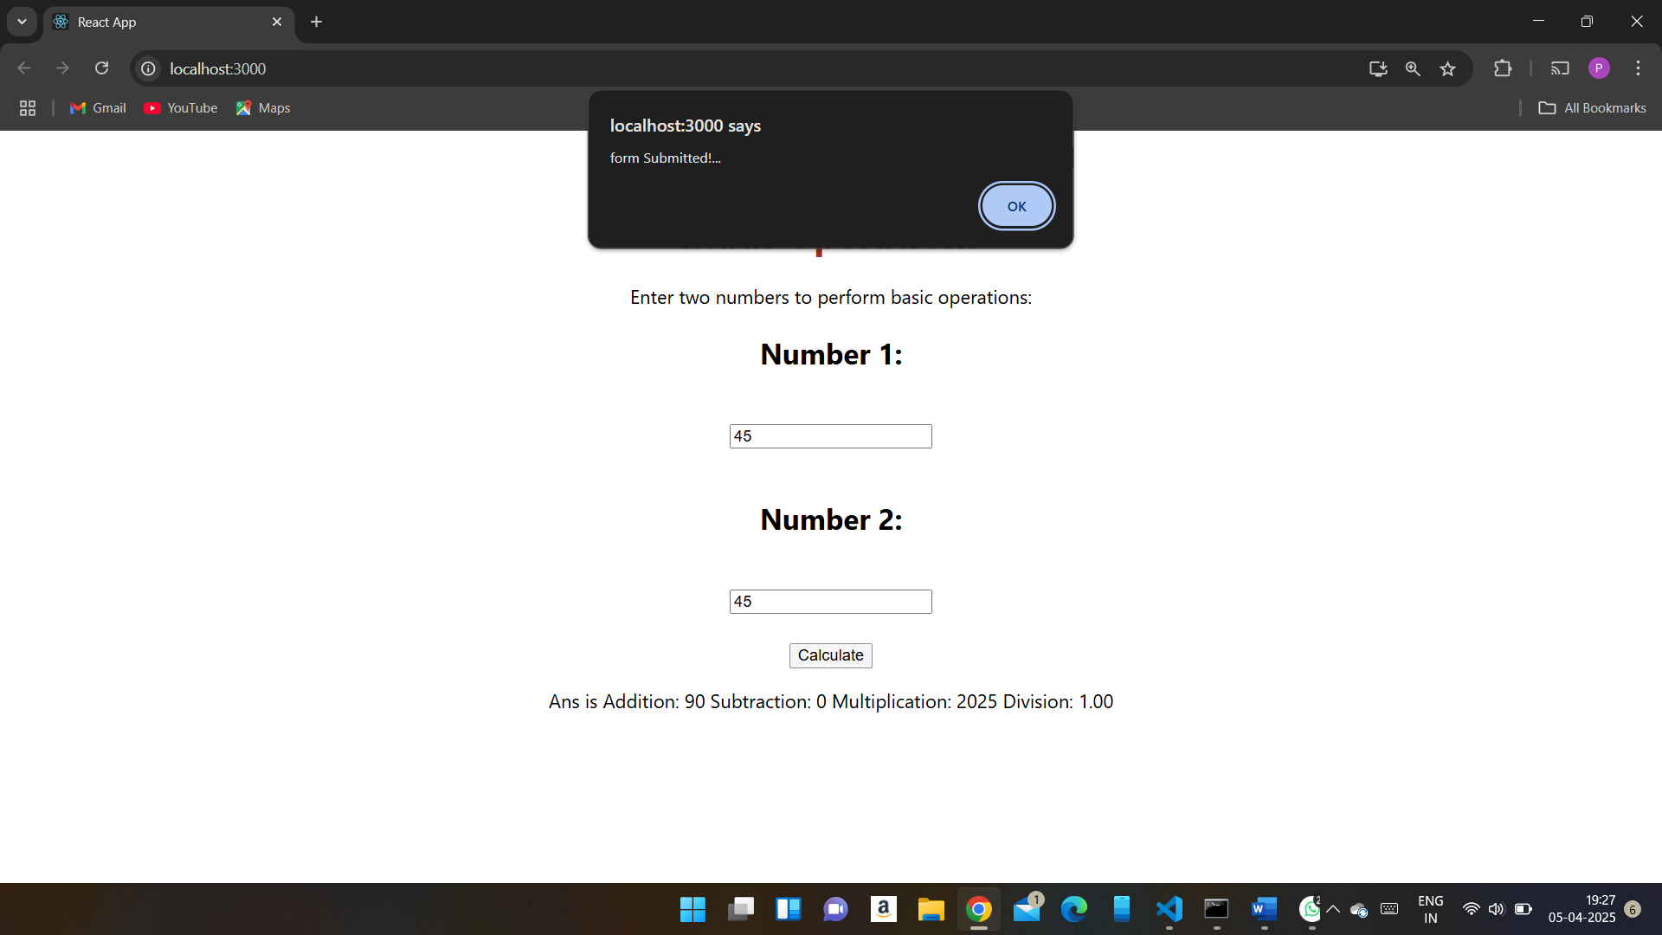

5. Create React.js Program to make Bank management System using React Function

Component.

useState Hooks:

• balance: Holds the current account balance.

• amount: Stores the user input amount.

• message: Displays deposit, withdrawal, or balance check messages.

Functions:

• depositAmount(): Adds the input amount to the balance.

• withdrawAmount(): Deducts the input amount if sufficient balance exists.

• checkBalance(): Displays the current balance.

Event Handling:

• onChange updates the amount state when the user types.

• Button clicks trigger the respective functions.

import React, { useState } from 'react';

function Bankmanagment(){

    const [name,setname] = useState('');

    const [balance,setbalance] = useState('');

    const [amount,setamount] = useState('');

    const [isAccountcreated,setisAccountcreated] = useState(null);

       const createAccount = () => {

        if(name !== ""){

            setbalance(0);

            setisAccountcreated(true);

            alert("Account created sucsefully");

        }

        else{

            alert("enter the valid name");

        }

       };

       const deposite = () => {

        setbalance(balance+parseFloat(amount));

       };

       const withdraw = () => {

        if(amount <= balance){

            setbalance(balance-parseFloat(amount));

        }

        else{

            alert("insuffisient balance!");

        }

        setamount("");

       };

       const checkbalance = () => {

        alert(`your current balance is ${balance}`);

        // setbalance(balance);

       }

    return(

    <div className="p-4 text-center">

        {!isAccountcreated ? (

        <div>

        <h1>Enter the name</h1>

        <input

        // type="text"

        value={name}

        placeholder='enter the name'

        style={{ height: "35px",width: "200px",backgroundColor: "lightpink"}}

        onChange={(e) => setname(e.target.value)}

        />

        <br></br>

        <br></br>

        <button onClick={createAccount}>Create Account</button>

        <br/>

        </div>

    ):(

        <div>

            <h2>Welcome , {name}</h2>

            <br></br>

        <h2>balance : {balance}</h2>

        <br/><h1>Enter the amount</h1>

        <input

        // type="text"

        value={amount}

        placeholder='enter the ammount'

        style={{ height: "35px",width: "200px",backgroundColor: "lightpink"}}

        onChange={(e) => setamount(e.target.value)}

        />

        <br/><br/>

        <button  onClick={withdraw} style={{color: "black",backgroundColor: "lightblue",width: "200px",height: "35px",fontSize: "20px"}}>withdraw</button>

        <br></br>

        <button  onClick={deposite} style={{color: "black",backgroundColor: "lightblue",width: "200px",height: "35px",fontSize: "20px"}}>deposite</button>

        <br></br>

        <button  onClick={checkbalance} style={{color: "black",backgroundColor: "lightblue",width: "200px",height: "35px",fontSize: "20px"}}>checkbalance</button>

        </div>

       )}

        </div>

    );

}

export default Bankmanagment;

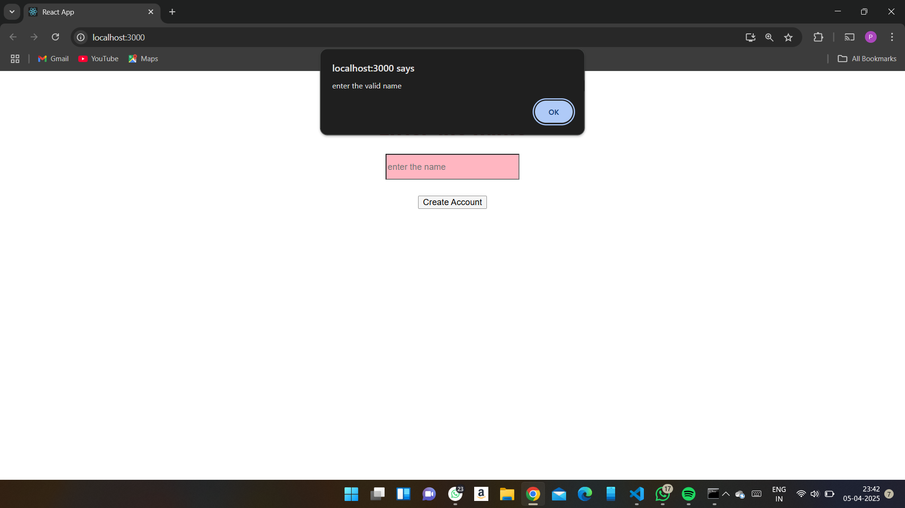

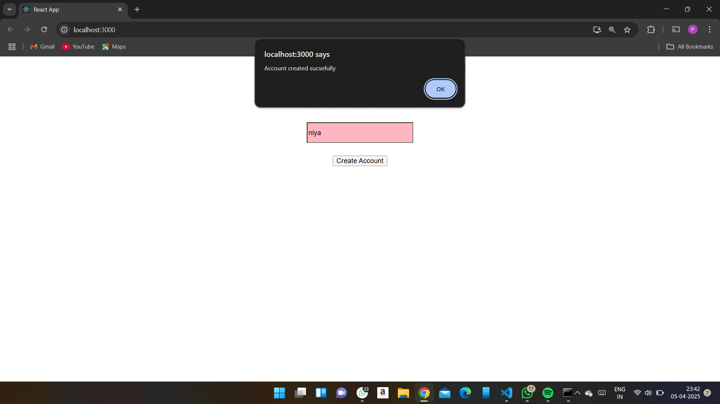

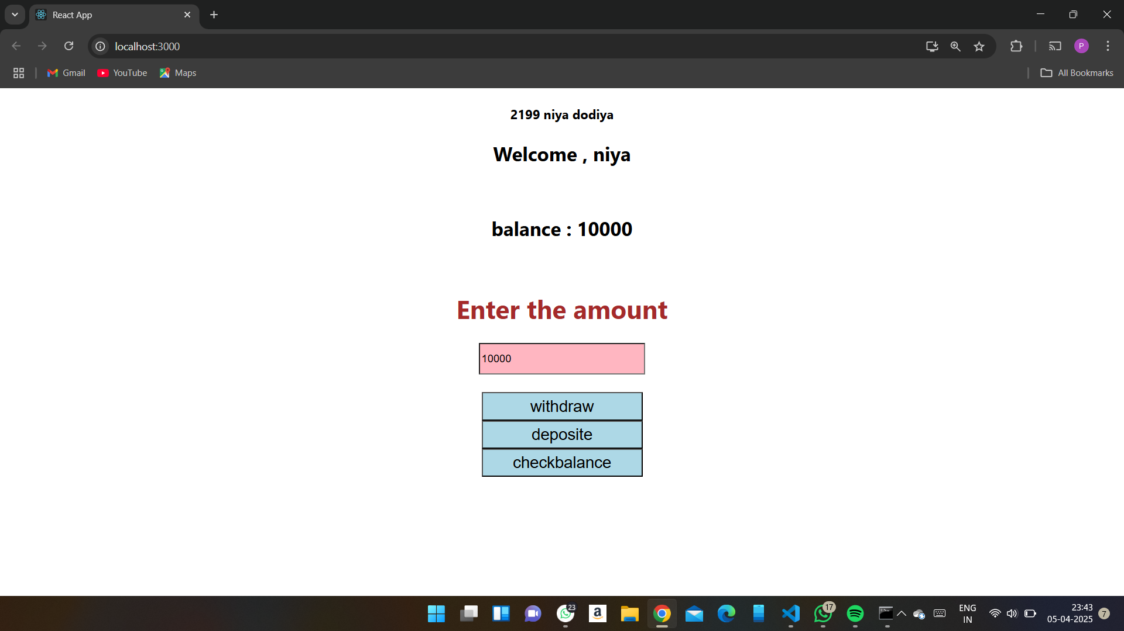

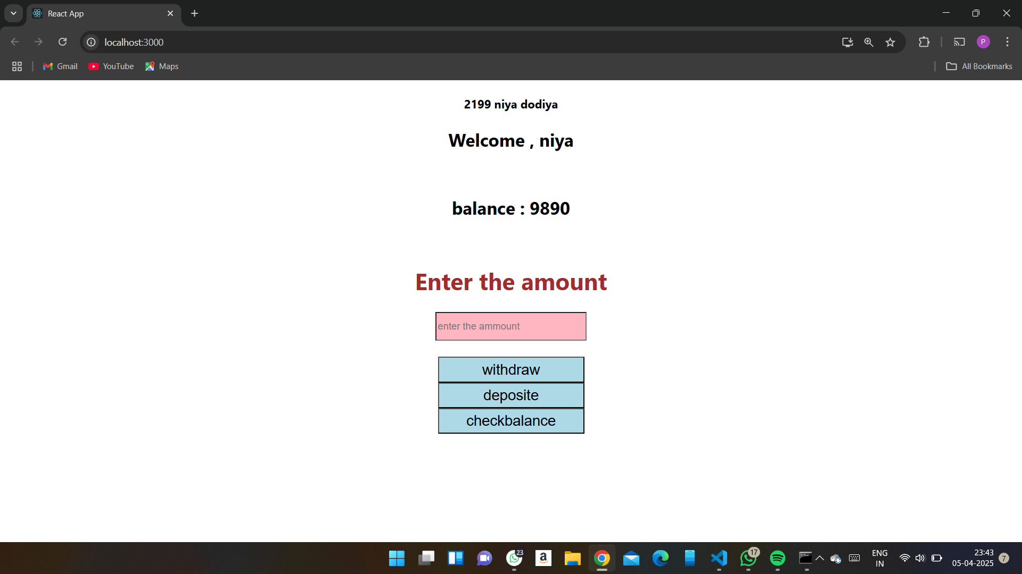

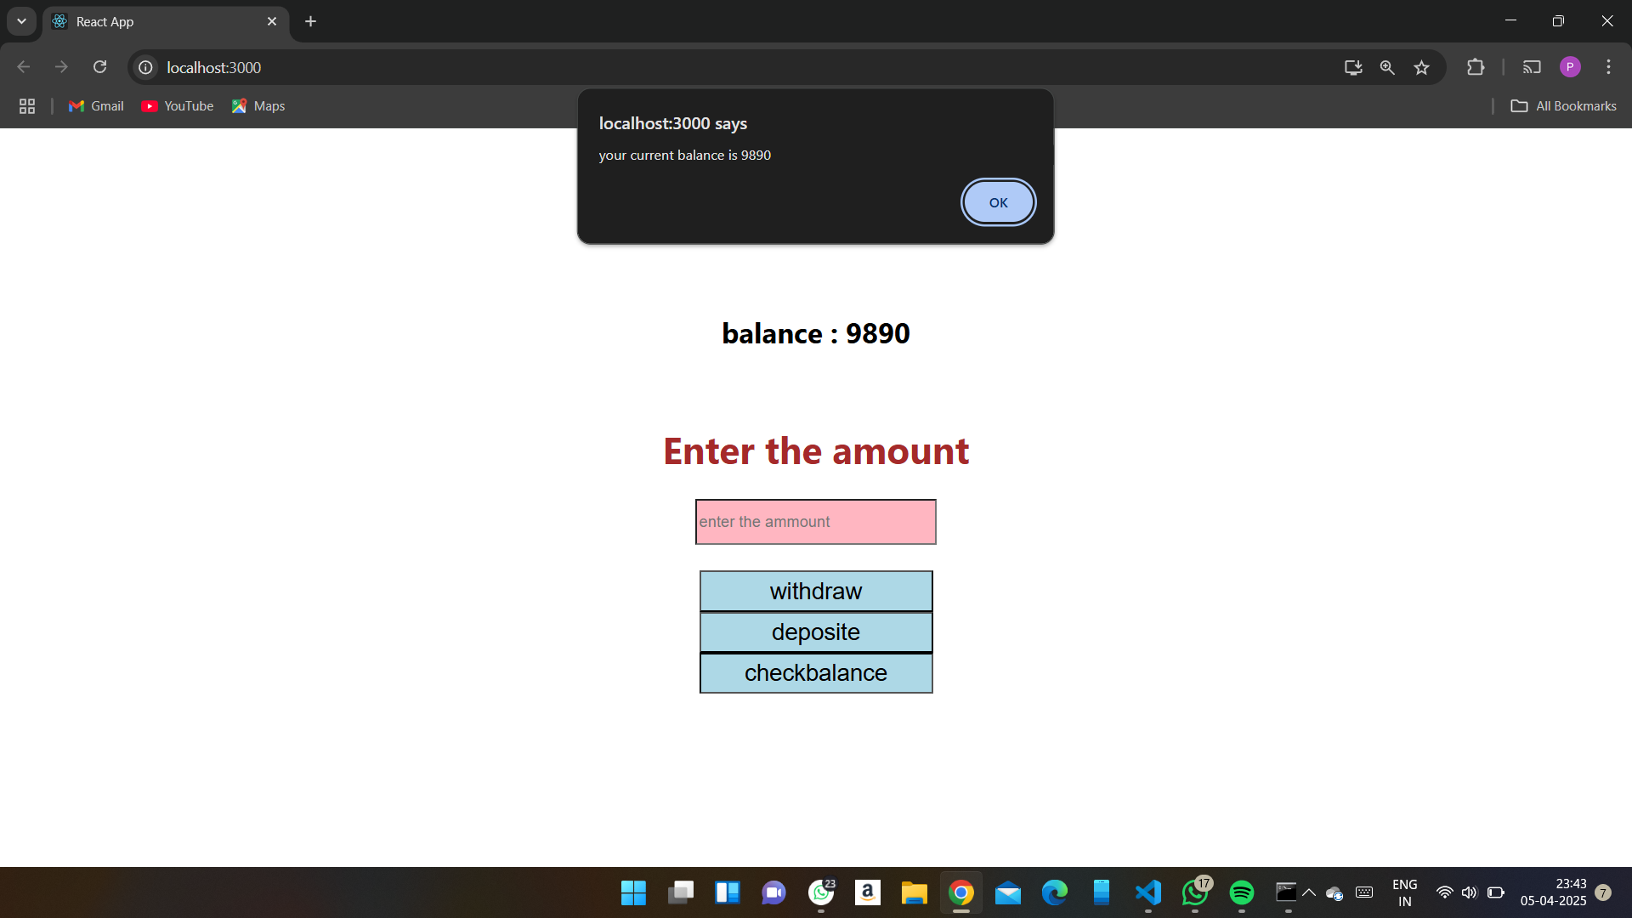

6. Create Registration form using React js.Employee_name , Email_id , Password,

contact number.Using UseState Hook. Value change dynamically.Apply External css in

form. Include Validation in name , Emailid and password. Use regular Expression in

email_id and password.

import React, { useState } from 'react';

import './App.css'

function Formvalidation() {

    const [name,setname] = useState('');

    const [email,setemail] = useState('');

    const [password,setpassword] = useState('');

const validation = () => {

   if (!name || !email || !password) {

      alert("all feilds are nessasary")

    }

    if(name.length < 3){

        alert("username must be atlest 3 or more charactes");

    }

    if(!email.includes('@')){

        alert("emial are include @ ");

    }

    if(password.length < 8){

        alert("password must be atlest 8 or more charactes");

    }

    else{

        alert("Form Submitted Sucsefully");

    }

    };

    // render(){

        return(

            <>

        <h2>Employee Validation Form</h2>

        <input

        // type="text"

        value={name}

        placeholder='enter the name'

        style={{ height: "35px",width: "200px",backgroundColor: "lightpink"}}

        onChange={(e) => setname(e.target.value)}

        />

        <br/><br/>

        <input

        // type="number"

        value={email}

        placeholder='enter the email'

        style={{ height: "35px",width: "200px",backgroundColor: "lightpink"}}

        onChange={(e) => setemail(e.target.value)}

         />

        <br/><br/>

        <input

        // type="number"

        value={password}

        placeholder='enter the address'

        style={{ height: "35px",width: "200px",backgroundColor: "lightpink"}}

        onChange={(e) => setpassword(e.target.value)}

        />

        <br/><br/>

        <button  onClick={validation} style={{color: "black",backgroundColor: "lightblue",width: "100px",height: "35px",fontSize: "20px"}}>Submit</button>

        <br/>

        <h2>Name : {name}</h2>

        <h2>Email : {email}</h2>

        <h2>Password : {password}</h2>

        </>

        )

    }

export default Formvalidation;

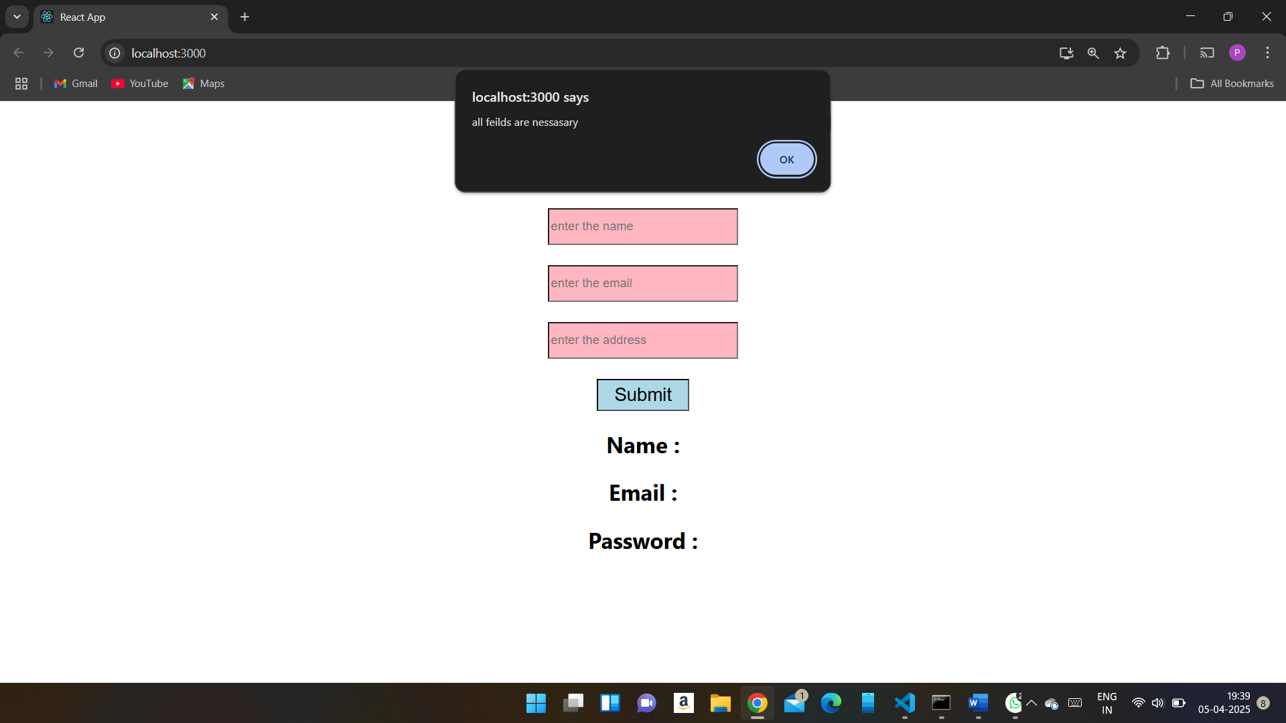

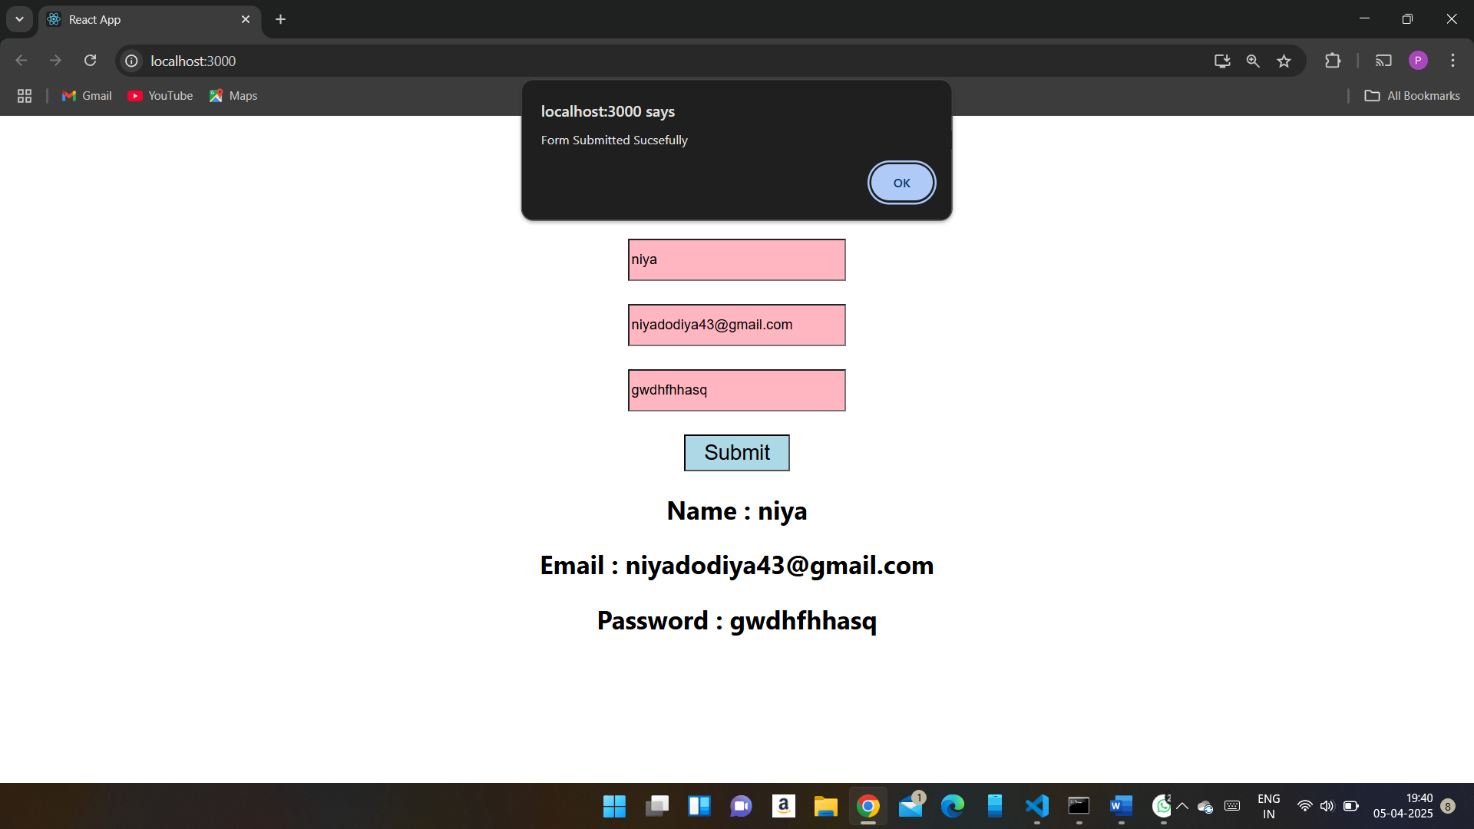

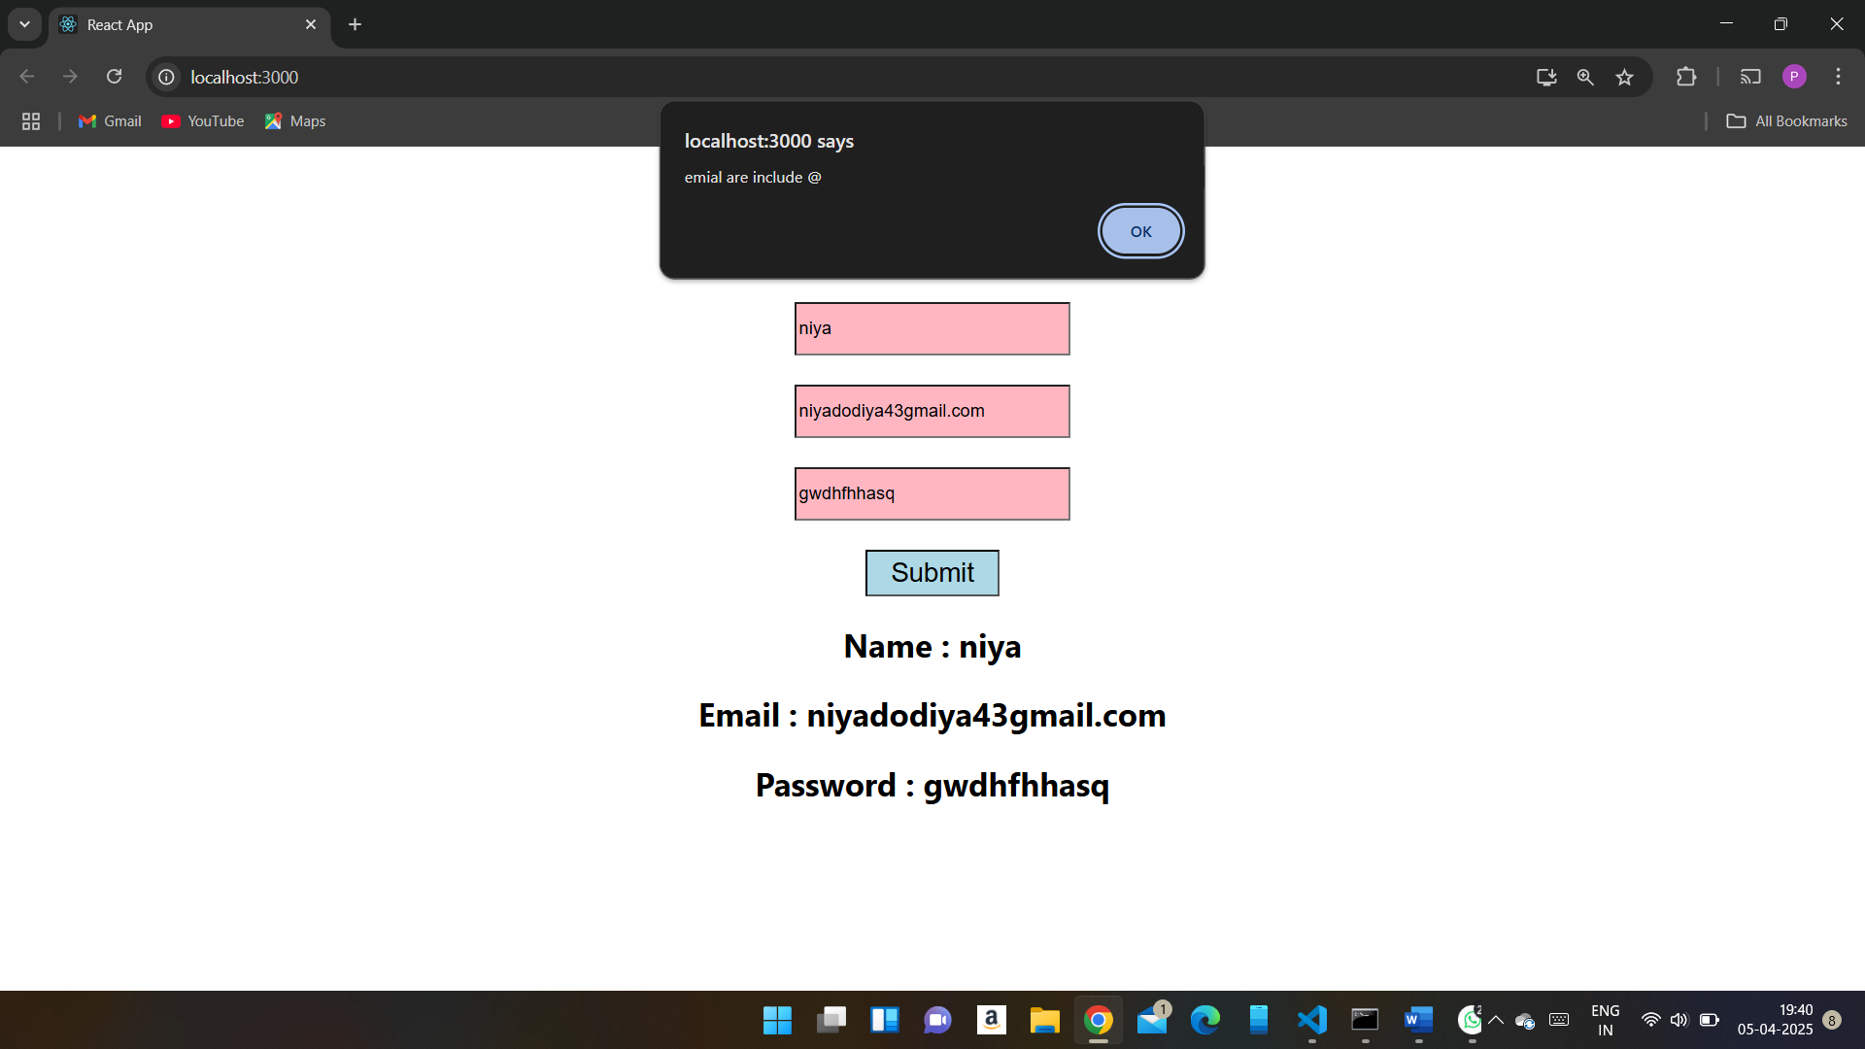

7. Create React Program which calculates the area of a rectangle and a circle using

functional components and state. Value change dynamically.

import React, { useState } from 'react';

function Area(){

    const [radius,setradius] = useState('');

    const [height,setheight] = useState('');

    const [width,setwidth] = useState('');

    const [circlearea,setcirclearea] = useState(null);

    const [retanglearea,setretanglearea] = useState(null);

       const calculateCircleArea = () => {

        const area = Math.PI*radius*radius;

        setcirclearea(area);

       };

       const calculateRetangleArea = () => {

        const area = height*width;

        setretanglearea(area);

       };

    return(

        <>

        <h1>Enter the radius</h1>

        <input

        // type="text"

        value={radius}

        placeholder='enter the name'

        style={{ height: "35px",width: "200px",backgroundColor: "lightpink"}}

        onChange={(e) => setradius(e.target.value)}

        />

        <br/>

        <button  onClick={calculateCircleArea} style={{color: "black",backgroundColor: "lightblue",width: "100px",height: "35px",fontSize: "20px"}}>Submit</button>

        <h1>Area of circle : {circlearea}</h1>

        <br/>

        <h1>Enter the height</h1>

        <input

        // type="text"

        value={height}

        placeholder='enter the name'

        style={{ height: "35px",width: "200px",backgroundColor: "lightpink"}}

        onChange={(e) => setheight(e.target.value)}

        />

        <br/><br/><h1>Enter the width</h1>

        <input

        // type="text"

        value={width}

        placeholder='enter the name'

        style={{ height: "35px",width: "200px",backgroundColor: "lightpink"}}

        onChange={(e) => setwidth(e.target.value)}

        />

        <br/><br/>

        <button  onClick={calculateRetangleArea} style={{color: "black",backgroundColor: "lightblue",width: "100px",height: "35px",fontSize: "20px"}}>Submit</button>

        <h1>Area of Retangle : {retanglearea}</h1>

        </>

    )

}

export default Area;

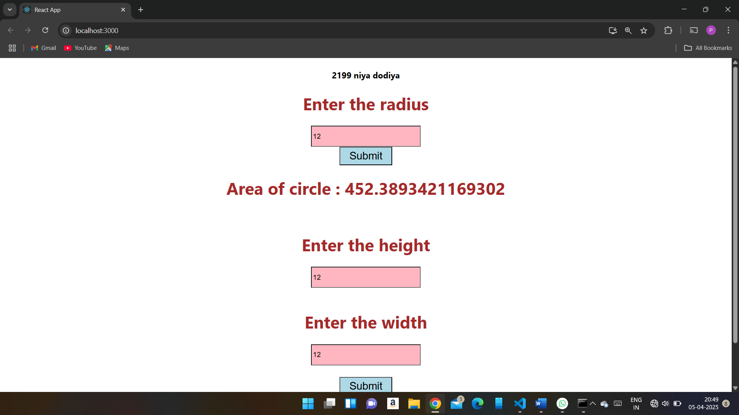

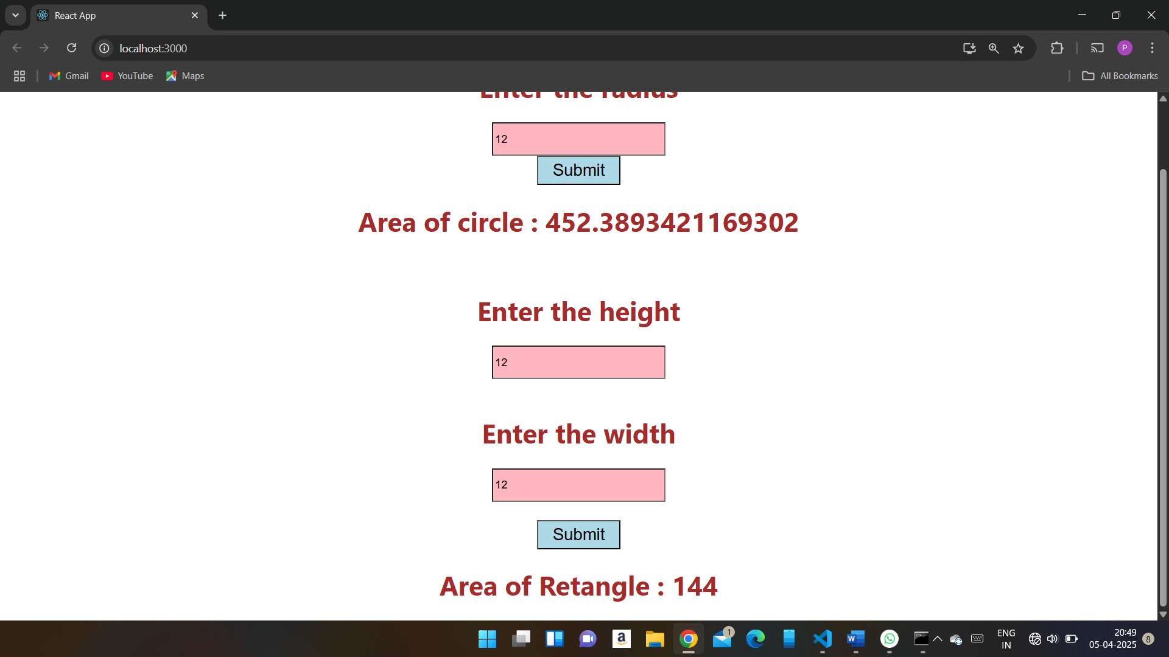

8. Create React Program using Function component to write Paragraph and print name

, age , address in paragraph using Props.

import React, { Component } from 'react';

import Demo from './Demo';

// import '../styles/ExpenseEntryItem.css'

import './App.css'

lass Democlas extends Component{

    render(){

        return(

            <>

            <h1>

                Name:{this.props.name}

                <br/>

                Age:{this.props.age}

                <br/>

                Address:{this.props.address}

            </h1>

            </>

        )

    }

}

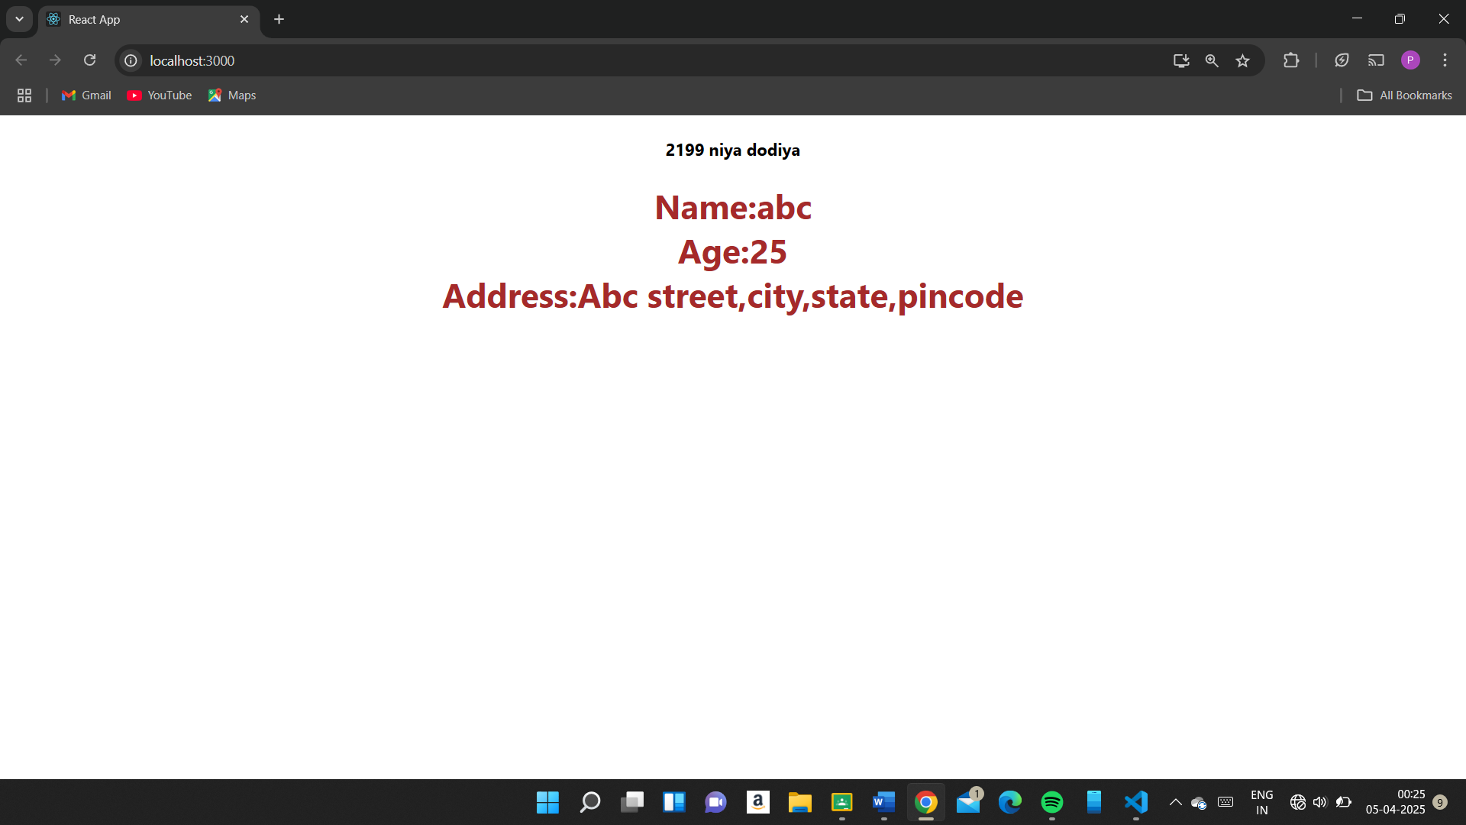

9. Create a Form using react js. Take Username , Address , email id using submit event.

And username input character count and display text.

import React, { useState } from 'react';

// import Demo from './Demo';

// import '../styles/ExpenseEntryItem.css'

import './App.css'

function Formvalidation() {

    const [name,setname] = useState('');

    const [email,setemail] = useState('');

    const [address,setaddress] = useState('');

const validation = () => {

   if (!name || !email || !address) {

      alert("all feilds are nessasary")

    }

    if(name.length < 3){

        alert("username must be atlest 3 or more charactes");

    }

    if(!email.includes('@')){

        alert("emial are include @ ");

    }

    if(address.length < 10){

        alert("address must be atlest 10 or more charactes");

    }

    };

    // render(){

        return(

            <>

        <h2>Student Geade Calculation</h2>

        <input

        // type="text"

        value={name}

        placeholder='enter the name'

        style={{ height: "35px",width: "200px",backgroundColor: "lightpink"}}

        onChange={(e) => setname(e.target.value)}

        />

        <br/><br/>

        <input

        // type="number"

        value={email}

        placeholder='enter the email'

        style={{ height: "35px",width: "200px",backgroundColor: "lightpink"}}

        onChange={(e) => setemail(e.target.value)}

         />

        <br/><br/>

        <input

        // type="number"

        value={address}

        placeholder='enter the address'

        style={{ height: "35px",width: "200px",backgroundColor: "lightpink"}}

        onChange={(e) => setaddress(e.target.value)}

        />

        <br/><br/>

        <button  onClick={validation} style={{color: "black",backgroundColor: "lightblue",width: "100px",height: "35px",fontSize: "20px"}}>Submit</button>

        <br/>

        <h2>Name : {name}</h2>

        <h2>Email : {email}</h2>

        <h2>Address : {address}</h2>

        </>

        )

    }

export default Formvalidation;

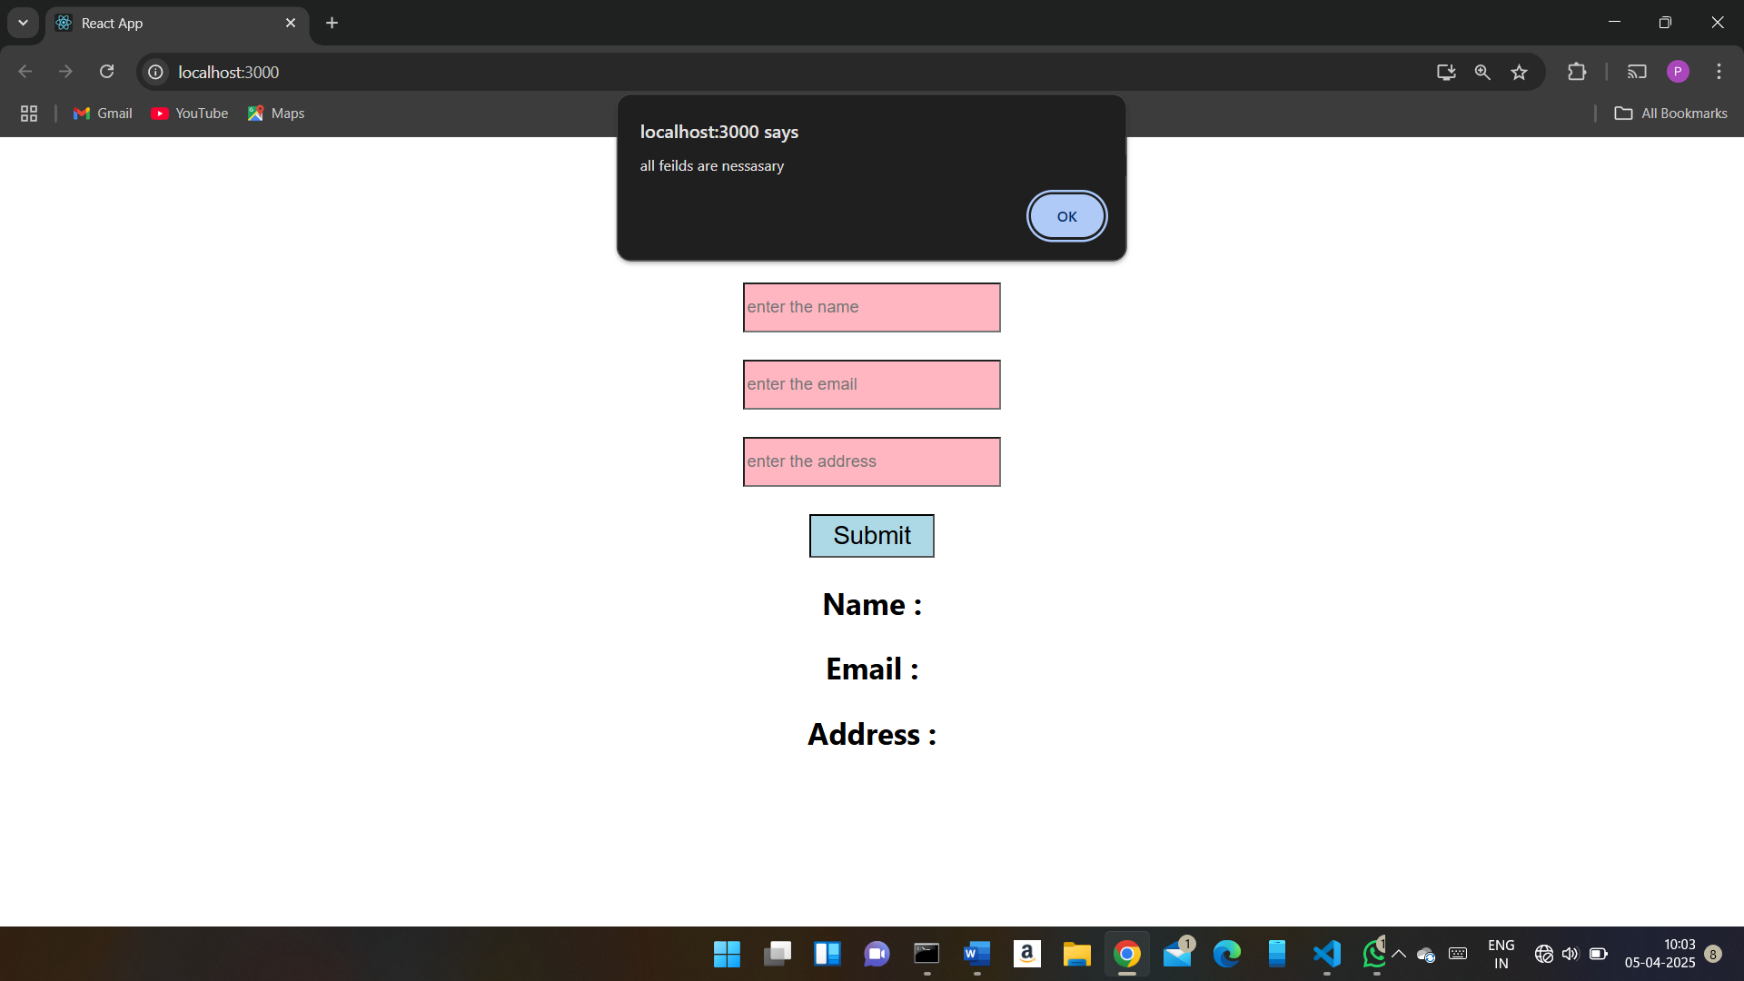

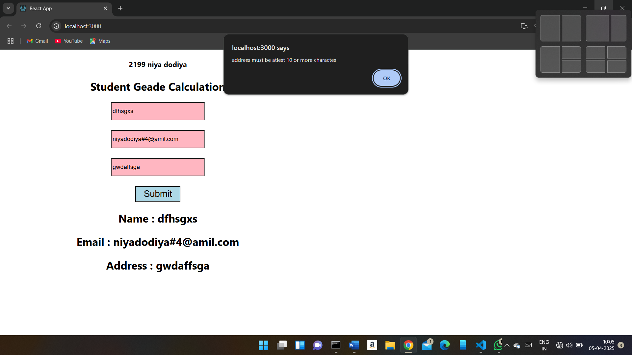

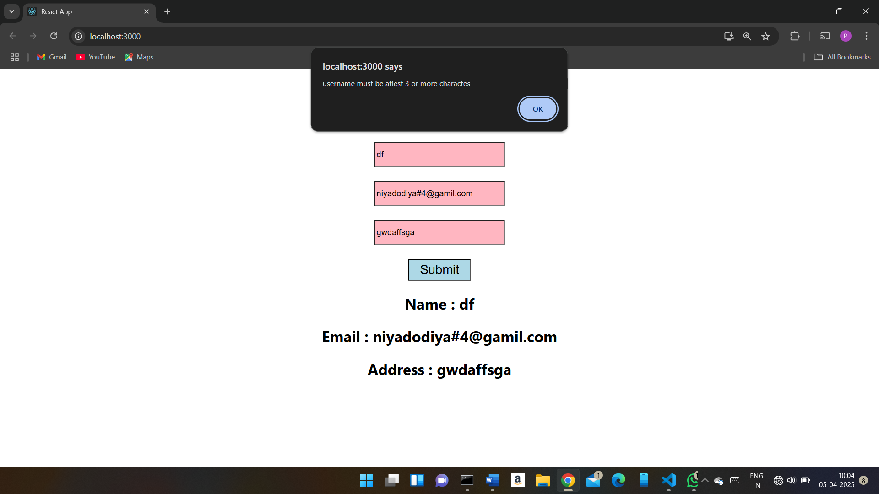

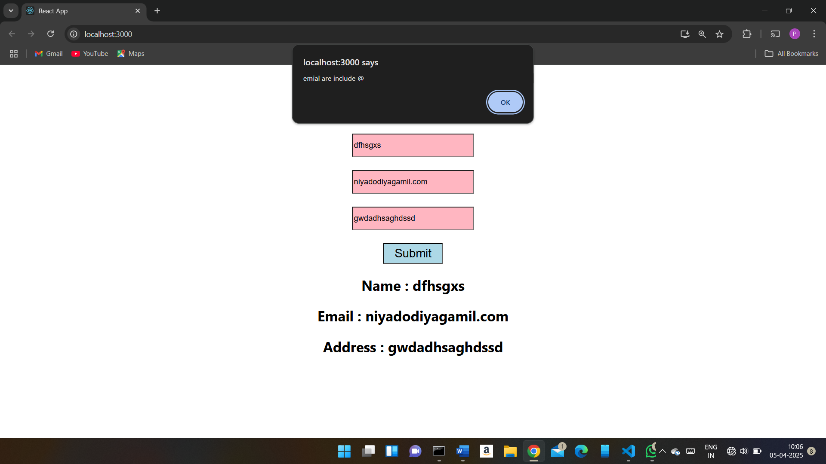

10. Create Reactjs program When user add 50 up score print in green color and user add

import React from "react";

function ScoreDisplay({Score}) {

    // render(){

        return(

            <>

            <h2>Score Display</h2>

            <p style={{color: Score >= 50 ? "green" : "red"}}>

            <h3>your Score: {Score}</h3>

            </p>

            </>

        );

    }

export default ScoreDisplay;

